### 5.2.3 Manage Cohort

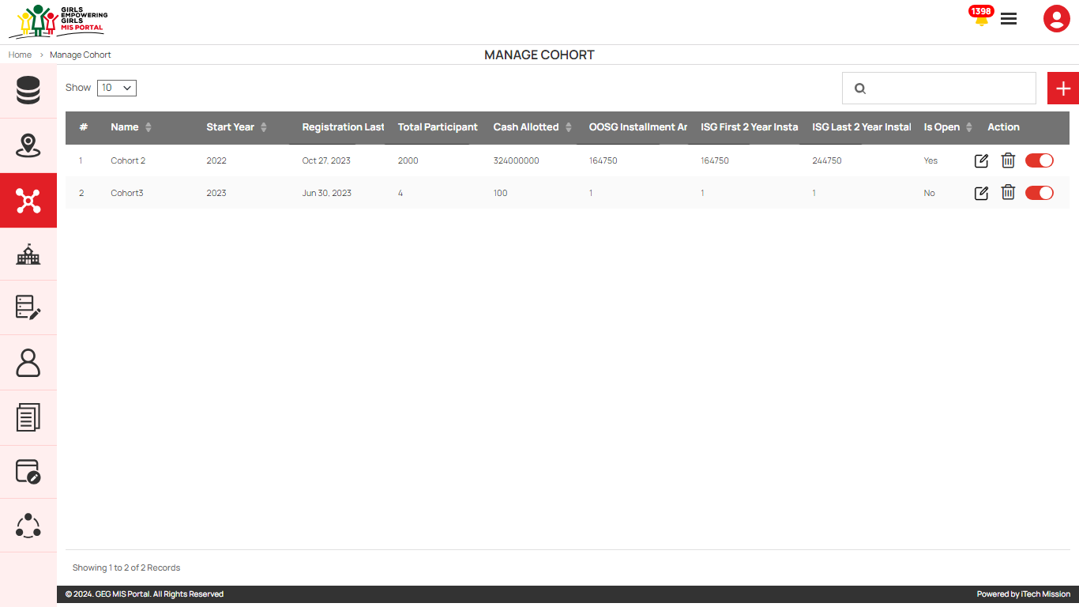To access this module, click on the **Manage** **Cohort** menu option in the left panel. This module allows to management of the Cohort master list. You will have options to add new cohorts, view the list of existing cohorts, sort the list, search cohorts from the list, delete, edit, and enable/disable existing cohorts (see figure below). ). Below is the step-by-step guide on how to use this module.

**Step 1** – Select Admin from the burger menu, then click on Manage Cohort to manage the master list of Cohort.

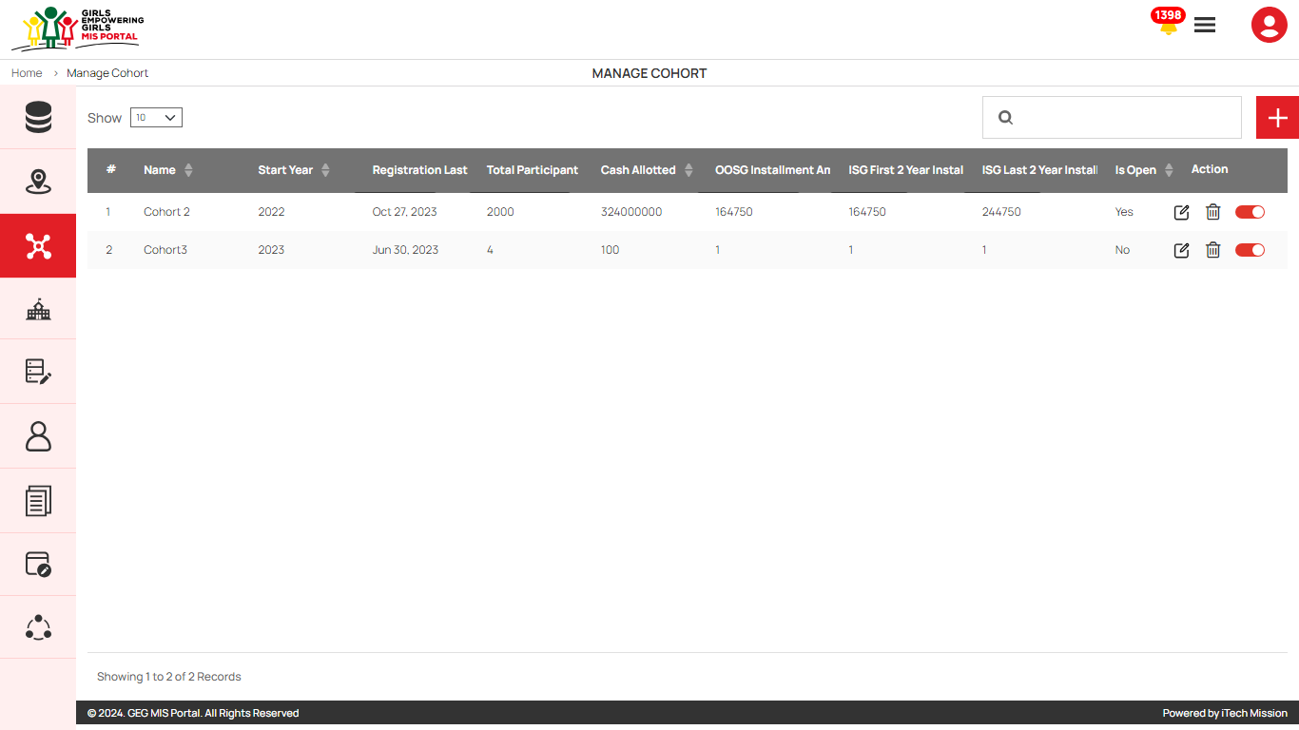**Step 2** – Click on the Add button to insert a new Cohort to the list and fill in the specified details - Area, Name, Start Year, Registration Last Date, Date, Total Participant, Installment (in UGX), Category 1 * OOSG & Primary ISG, Category 2 * OOSG & Primary ISG with disability, Category 3 * Secondary ISG, Category 4 * Secondary ISG with disability, Description and Is Open.

**Step 3** – Click the Edit icon to update the existing cohort data .

**Step 4** – Click on the Delete icon to delete the existing Cohort

**Step 5** –Click on the Toggle button to update the status of the cohort.

#### Add Cohort

Click on the **Plus** button available on the right side of the page to **add** a new cohort (see figure below). Enter the following details to add a new cohort.

* Select **Area**
* Enter **Name**
* Select **Start** **Year**
* Enter **Registration Last Date**
* Enter **Date**
* Enter **Total** **Participant**
* Enter **Installment (in UGX)**
* Enter **Category 1** * OOSG & Primary ISG
* Enter **Category 2** * OOSG & Primary ISG with disability
* Enter **Category 3 \*** Secondary ISG
* Enter **Category 4** * Secondary ISG with disability
* Enter **Description**
* Select **Is Open**

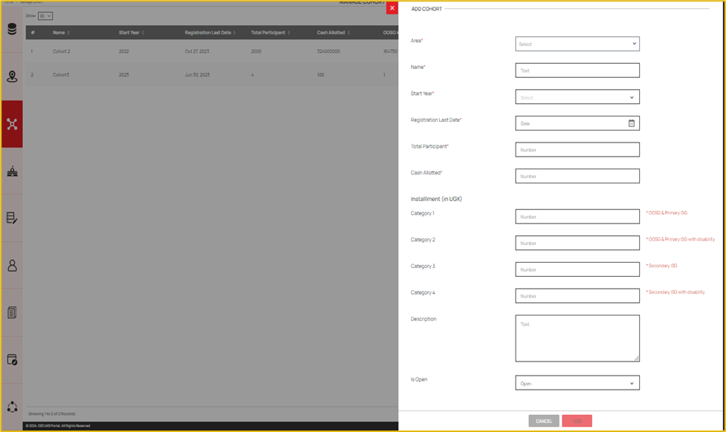All the details apart from the cohort description are mandatory to be entered. Click on the **Add** button to save and confirm. You can now view the new cohort added to the cohort list.

You can edit a cohort by clicking on the **Edit** button from the Action column. When you click on the edit button the edit cohort form will open where you can edit any detail of the cohort. Edit the required detail and click on the Update button to save and confirm.

You can delete a cohort by clicking on the **Delete** button from the Action column. When deleting a cohort, a confirmation popup will appear to confirm the deletion. If clicked Yes, the selected record will be deleted.

Click on the **Status** button to enable or disable the specific cohort. All the records of the disabled cohort will not be shown in the overall application.